475 Moe Road, Clifton Park, NY 12065  Email: friendsofthecphlibrary@gmail.com  Friend’s website: www.friendsofcphlibrary.org  Library website: www.cphlibrary.org  Referred by: _____________________________  Promo Date: ____________________________ | 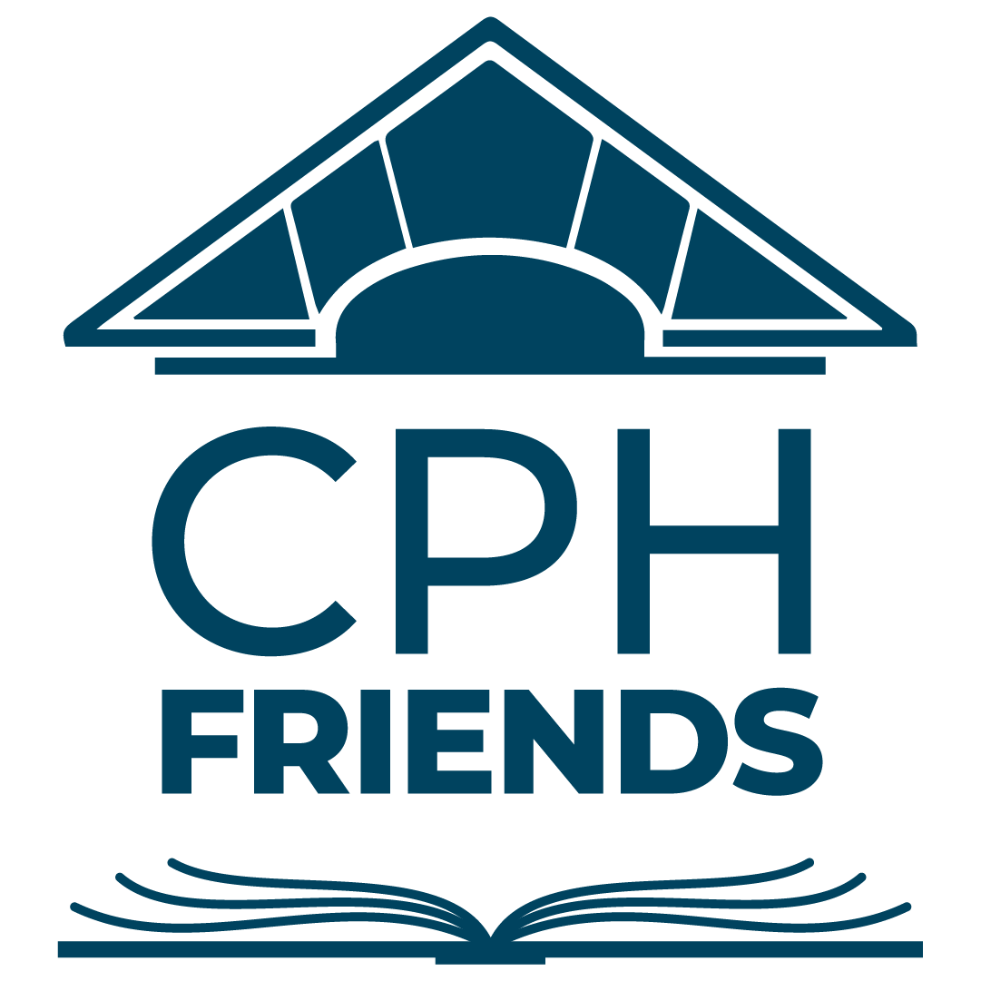 | FOR OFFICE USE ONLY
 |  | Last Name: |  | Date Rec’d:  Coupon Issued
 |  | Ck #: | Ck. Amt.: $ | Date Rec’d:  Coupon Issued
 |  | Cash: $ | Entered: | Date Rec’d:  Coupon Issued
 |  | Venmo: $ | Entered: | Date Rec’d:  Coupon Issued

FRIENDS OF THE LIBRARY (FOL) MEMBERSHIP FORM

Level and Amount |  | UBS  Coupon | Benefits
Bookworm | $5 | $1 | Early 1st Day Admission to Used Book Sales, Discounts on FOL Bus Trips
Book Lover | $10 | $2 | All the above, Plus an Additional Membership *
Bibliophile | $25 | $5 | All the above, Plus an Additional Membership *
Book Collector | $50 | $10 | All the above, Plus an Additional Membership *
Conservator | $100 | $15 | All the above, Plus an Additional Membership *
Curator | $250 | $20 | All the above, Plus a Small Paver (Curator) or a Large Paver (Reserve List)
Reserve List | $500 | $25

Please complete this form and return it with your donation to the Library Ask Desk or Circulation Desk, OR, mail it with your donation to:
Friends of the Clifton Park-Halfmoon Public Library
475 Moe Road, Clifton Park, NY 12065
Note: If you are renewing, you only need to complete your name(s) and any information that needs to be updated.
* If you join at the $10 level or higher, you may list an additional member to ensure both receive admission to our Members Only Sale on the first day of our Used Book Sale. An additional member will be listed under the primary member’s mailing address.

Print Primary Member Name: |  | Check Membership Type:  New Renewal
Print Additional Member Name if Applicable: |  | Check Membership Type:  New Renewal
Street Address: | City: State: Zip:
Phone(s): Note preferred phone number with :

Home: __________________________________ Mobile: __________________________________
Email, Primary Member (Please Print):

Email, Additional Member (Please Print):

Check here if you would like to receive information about volunteer opportunities with the Friends of the Library!

I have enclosed my $________ membership donation. Please check : Cash Check Venmo Date: __________________

Please note that all membership correspondence, including membership renewal notices, is sent via email. If you do not have email, you can access the FOL blog and calendar of events on any computer, tablet, or smartphone by going to our website (www.friendsofcphlibrary.org). During the Members Only portion of each used book sale, we will have a list of all current members, so membership cards are not necessary.

The Venmo payment option is available for members joining at the $10 level or higher. (Search for "CPH". We are listed under "Charities".)
The PayPal payment option is available on our website (www.friendsofcphlibrary.org) for members joining at the $25 level or higher.

The FOL membership year runs twelve (12) months from the date of your initial membership or from your most recent renewal.
The Friends of the Clifton Park-Halfmoon Public Library is a 501(c)(3) not-for-profit organization. Your membership donation is tax deductible to the full extent allowed by law. You may wish to consult your tax professional for more information on deductions.

May 2025

