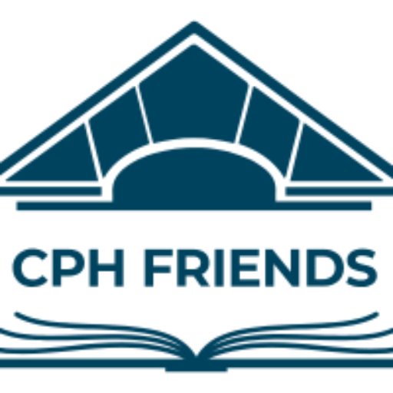
Friends of the Clifton Park-Halfmoon Public Library
Community Scholarship
(High School)
The Friends of the Clifton Park-Halfmoon Public Library Community Scholarship program assists deserving students in realizing their educational dreams. The Friends anticipate awarding two scholarships of $1,000 each to students who will attend an accredited two- or four-year college or university.
Guidelines
There are five required parts to this application. The first four are to be completed by the applicant. Application packets that are incomplete will not be reviewed. The fifth part of the application (see #5 below) must be completed by an individual who agrees to serve as a reference for the applicant. For ease of copying all submissions should be printed on only one side of each page. The application must include ALL of the following to be eligible:

1. Applicant’s personal information, including: name, address, telephone number, and email.

2. Applicant's academic information, including: name of high school (indicate if home-schooled);

3. A resume that includes information about activities, honors and awards, participation in school, extracurricular, civic and/or leadership activities, and work experience. List should encompass high school years only.

4. The original essay of at least 200 words must be typed double-spaced, and the applicant's name should appear on each numbered page. The essay must address the topic on the application.

5. Applicants must submit one letter of recommendation. The letter must be from someone other than a family member who has known the applicant for a sufficient time to be able to comment on his/her character and abilities. Do not submit more than one letter.
Application Package
The application form and all attachments must be received at the Clifton Park Halfmoon Library no later than February 27, 2026. Applications MAY NOT be faxed or emailed. Application packages that are incomplete or received after the deadline will not be reviewed.
Applications should be mailed or taken in person to:
Friends of the Clifton Park-Halfmoon Public Library
Community Scholarship
475 Moe Road
Clifton Park, New York 12065
Eligibility
To be eligible, applicants must be:
1. Graduating seniors attending Shenendehowa High School
-OR
2. Graduating seniors living within the Clifton Park-Halfmoon Public Library tax district who are either a) attending another public/private high school or b) home-schooled
-AND
3. Entering their first year at an accredited two-year or four-year college or university in the fall of the scholarship year.
Scholarship Fund Disbursement
1. Scholarships must be used beginning in the fall semester of the scholarship year.
2. Award recipients will be contacted directly by the Awards Committee.

3. The check will be mailed to the student upon receipt by the FOL of documentation of your payment of eligible expenses totaling $1000.00 or more for tuition, room and board, and/or books.

4. Awards are for one year and are non-renewable.

Friends of the Clifton Park-Halfmoon Public Library
Community Scholarship
2026 Application
Part I – Student Information
__________________________________________________________________________________ Last Name First Name M.I.
__________________________________________________________________________________ Street (Permanent Address)
__________________________________________________________________________________ City State Zip
___________________________________ _____________________________________________
Phone Number Email Address

Part II – Academics
Name of High School You Attend ______________________________________________________ If you are not a Shenendehowa student, do you live within the library tax district? Yes No
Expected Date of Graduation ________/________/________
Name and address of accredited college/university you anticipate attending in the fall. __________________________________________________________________________________ __________________________________________________________________________________ Part III – Resume
Please provide a resume that includes the following from your high school years only: awards/honors, extra-curricular activities, community/volunteer work, and employment. Please do NOT include a transcript.

Part IV – Essay
On a separate page(s), please provide a typed essay of no less than 200 words on the following:
You have been fortunate to grow up in a community that has a strong library. As you go forward in life, you may live in a city or town that does not have such a resource. It is our hope that you will become an active community member and will be able to be involved with your local library wherever you live. Write your essay from the following prompt:
Libraries have lasted thousands of years and no smartphone, search engine, or computer can ever replace the resourcefulness of a librarian or the reliability of a book.
But. . . imagine that the Clifton Park - Halfmoon Library has closed it's doors forever. What impact would this have on you? What impact would it have on your community? Use your imagination and think creatively. Consider all aspects of what the Library has to offer, the access to knowledge, the people, the programs and maybe even the physical space. What would we have lost by this closure?
Be very specific and use personal examples. Essays will be judged on content, AND on grammar and punctuation. Proofread your essay carefully, and correct all errors before submission. DO NOT rely on auto-correcting features on your devices. Great weight is put on a carefully written and thoughtful essay. A phone interview may be required.
Part V – Recommendation
Please provide one letter of recommendation from someone other than a family member, who has known you for a significant period of time and who can comment on your character and abilities.
Applicant Signature
__________________________________________________________________________________ Signature/ Date
Application Packet
Applicants must complete and submit all parts (I through V) of the application in one packet. Application packets must be received at the Clifton Park-Halfmoon Library no later than Friday, February 27, 2026. Applications MAY NOT be faxed or emailed. Application packets that are incomplete or received after the deadline will not be reviewed. Winners will be notified by May 1, 2026. Awards are for one year and are non-renewable.
Submit application packets to: Friends of the Clifton Park-Halfmoon Public Library
Community Scholarship
475 Moe Road
Clifton Park, New York 12065

Questions: Please contact Michele Gorab, Scholarship Chair, at michelegorab@gmail.com

