Friends of the Clifton Park-Halfmoon Public Library
2025 Annual Report

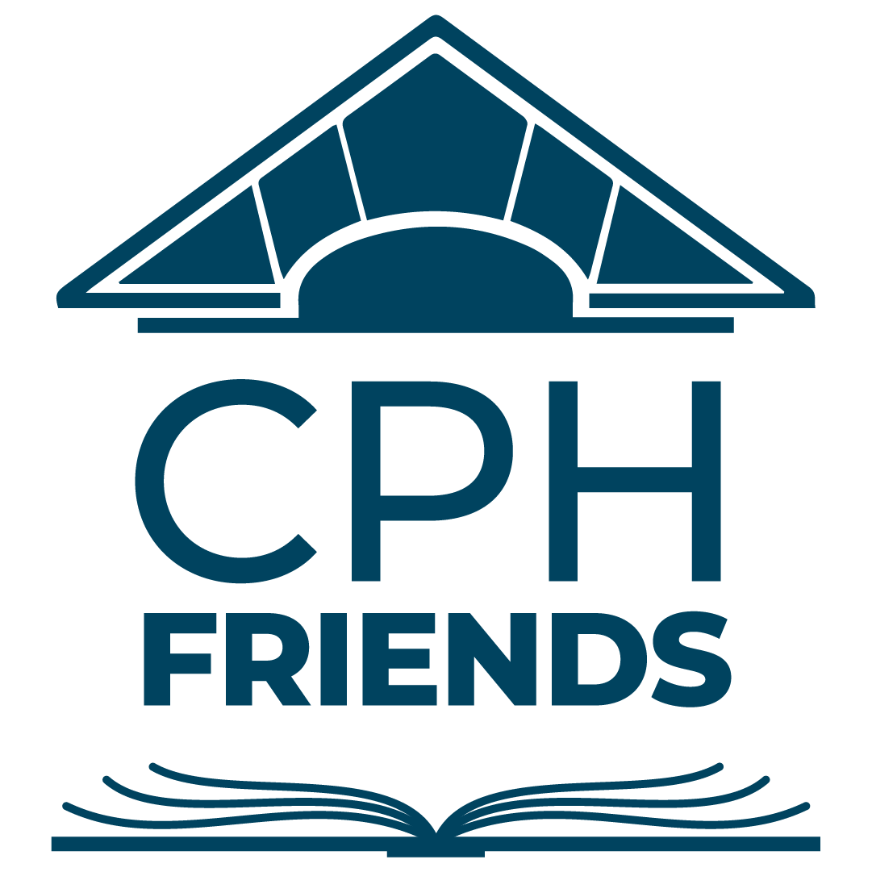

In 2025, The Friends of the Clifton-Park Halfmoon Public Library (“CPH Friends”) continued their efforts to fulfill their mission to act as a bridge between the library and community by working to increase public awareness of the library and raise funds to support library activities.

Key 2025 Initiatives
CPH Friends undertakes several key initiatives each year in support of the library and its communities.

Two Towns One Book - Community Read Program
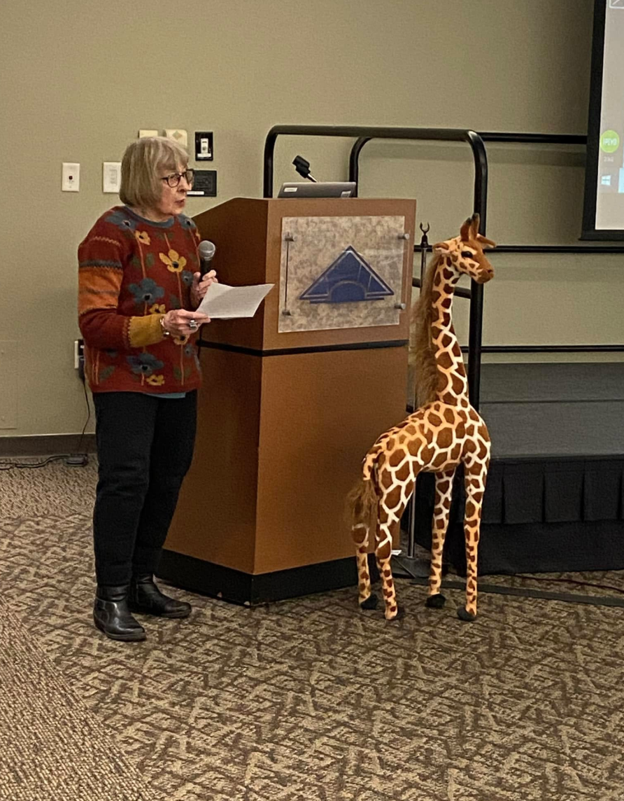
The year kicked off with our 13th annual Two Towns One Book (TTOB) community read, with programs centered around West with Giraffes by Lynda Rutledge during the first half of the year.

Programs were plentiful and focused on several of the book’s themes, including weather, the Great Depression, and wildlife. Meteorologist Reid Kisselback led the kickoff event with a discussion of hurricanes, including the Hurricane of 1938 that sets off the events in the novel. Another event - “Soup-er Saturday,” featured TTOB favorite Chef Abby Shea with a demonstration (and samples!) of low-budget vegetarian soups that would have stretched people’s dollar and stomachs during the Great Depression. Fan-favorite George Steele joined us for two programs - “Let’s Look at Wildlife” in March, which featured photos of a variety of wildlife he’d captured on trail cameras, and “A Sky That Sings,” which was offered as part of the Kids Read, Too! program and included an outdoor walk and listening to birds.

TTOB offerings rounded out with “What’s Wild in My Backyard,” which featured an expert panel on what to do when wild animals appear on your property, a program featuring Kate Dudding about stories of female pioneers mentioned in the novel, and a Shenendehowa HS photography exhibit that featured sepia photos - appropriate for the time period of West With Giraffes.
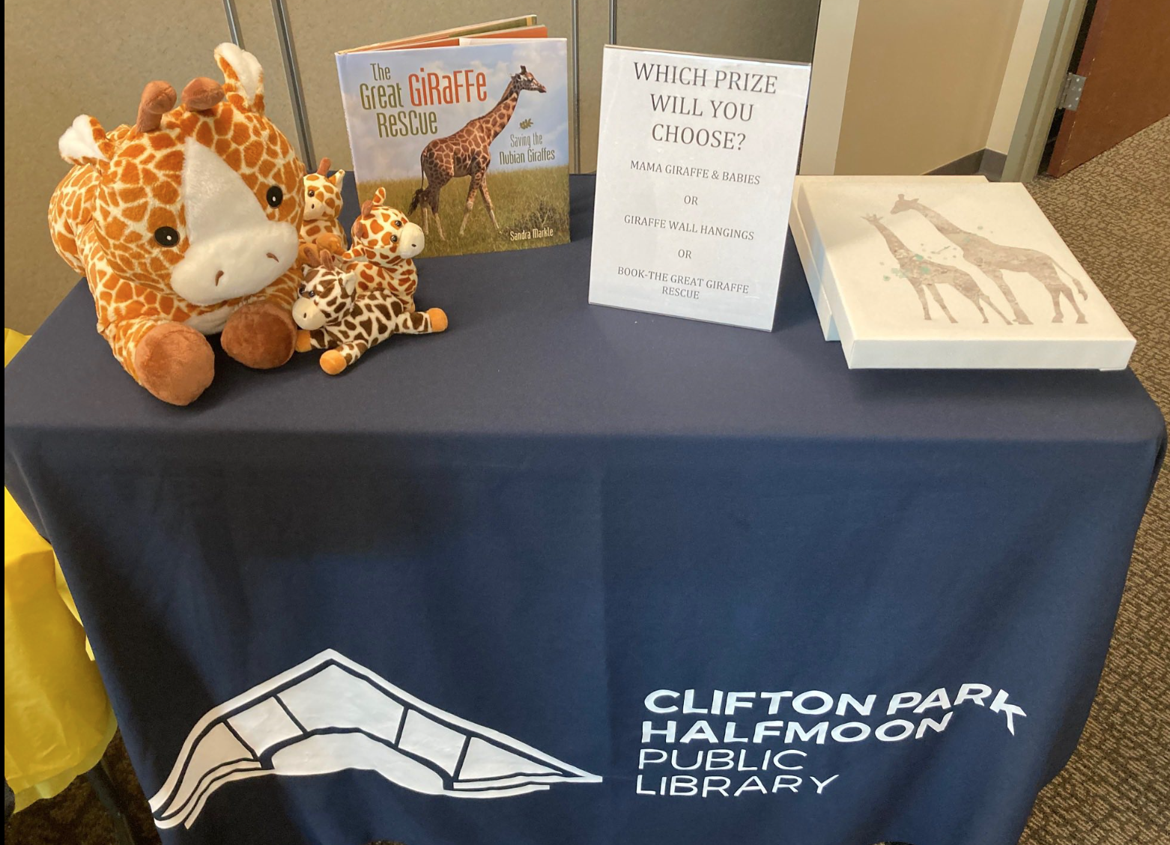
The efforts of the Two Towns One Book committee succeeded in bringing together the communities of Halfmoon and Clifton Park, with strong attendance at each event. They also engaged our youngest patrons with two “take-and-make” kits available during February and April school breaks. We also had fun with a giant giraffe at each program that was raffled off at the end of the season, a celebration of World Giraffe Day, and plenty of smaller giraffes along the way!

The latter half of the year focused on book selection for the 2026 community read, and included community participation during nominations and final vote. Following our TTOB book groups reading more than 20 books over the summer, community members selected The God of the Woods from five finalists in the fall. The selection was extra exciting this year, as CPH Library had already worked with CPH Friends to secure funding for an author visit by Liz Moore in April. Both the 2026 read and author event were announced around the same time, in coordination with the library.

Get Out the Vote
In advance of the library budget vote each fall, CPH Friends helps to garner support for the vote by placing lawn signs throughout Clifton Park and Halfmoon, and sending reminder emails to our email distribution list.

We also staffed a table just inside the foyer on the day of the budget vote, to express appreciation and hand out cider and cider donuts. We used this opportunity to increase our patron engagement and provide education about CPH Friends and the vote, helping to result in a 20% increase in voters from last year. The 2025 library budget vote passed by a margin of 741 to 123.

Fundraising Efforts
Used Book Sales
The 2025 Used Book Sales continued to generate strong interest both in our communities and throughout the Capital Region, generating more than $25,000 in income. In addition, our contingent of volunteers once again stepped up to make the sales great events for the CPH Friends and our customers. We welcomed Honor Society students from Christian Brothers Academy, who helped with the heavy lifting of setup before each sale.

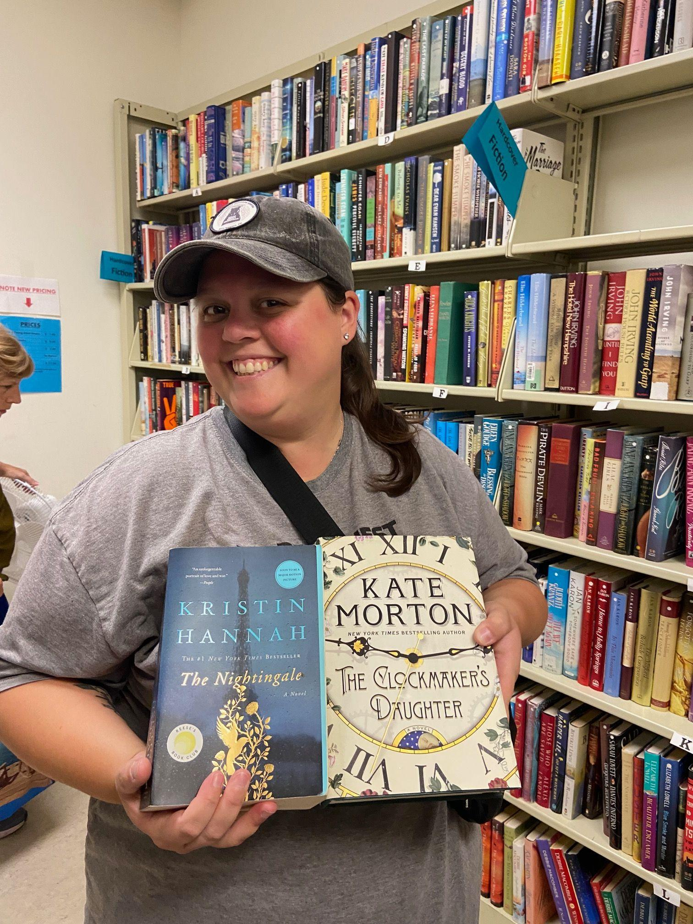
We continued to run “Dime Day” sales on Sunday, and invited patrons to “round up” to the nearest dollar to provide extra funds to the children’s library. The CPH Friends matched those donations, yielding a $1200 donation. Patrons could also purchase an extra children’s book to donate to the RED Bookshelf, another local nonprofit organization that promotes reading. We sent nearly 850 books as a result of donations.

We continued to tweak elements of the sale - including in the fall, when we nominally raised prices for the first time in as long as anyone could remember! All adult and young adult books are now priced at $1, with children’s books still at 50 cents. Customers still declared the prices a great deal!

We also changed the way we partner with the library for the Summer Reading Challenge. In the past, librarians would pull books in good condition as giveaways to challenge participants. To save time and to encourage our young readers to attend the book sales, the library issued a “Free Book coupon,” and those who completed the challenge could choose from a wider variety. Nearly 200 coupons were redeemed between the next two book sales.

Other Fundraisers
The third Crafters Supplies Give & Take once again brought in mountains of donated supplies. Community members shopped and made free-will donations they felt were appropriate for the supplies they chose to take home, resulting in over $5,500 in support of library programming. To build on this event, the committee is planning a second intake day for 2026.
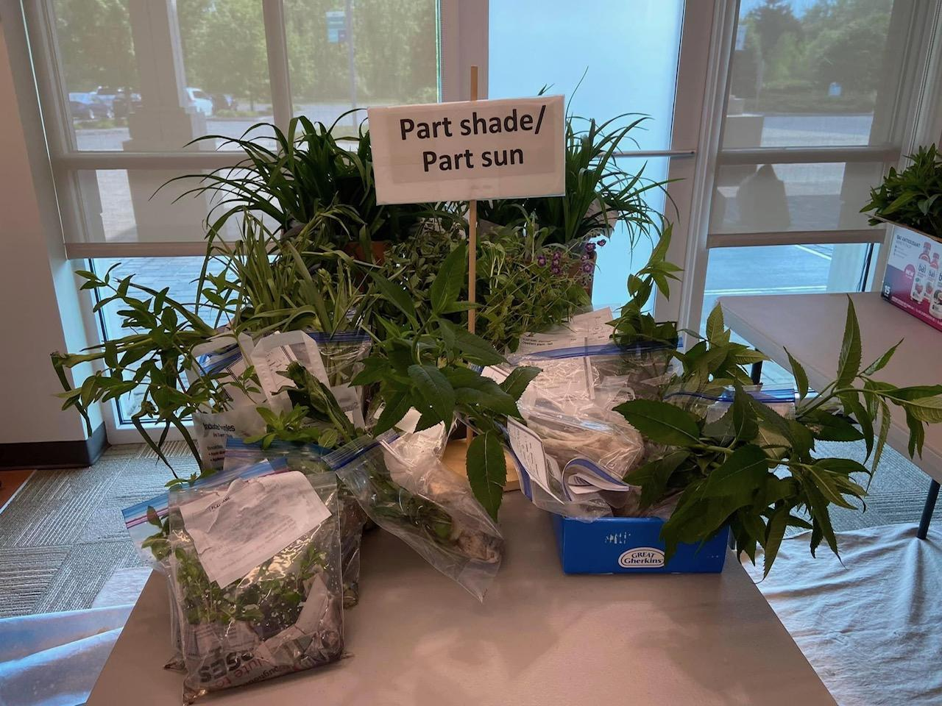

The popular Plant Give and Take event continued to follow the free-will donation based system similar to our Crafters Supplies Give and Take. We paired this with the Used Book Sale on the same weekend in May, with positive responses from those attending both events.

Travel
CPH Friends organizes worldwide travel for a group of those interested. In 2025, we hosted one bus trip to the NY Botanical Garden on September 14, which was a beautiful day and well-attended. We also went abroad for two trips in the fall - to Scandinavia in October, which featured a surprise highlight of being in Stockholm when the Nobel Prize Laureates were announced. CPH Friends returned to Europe in early December for a beautiful trip along the Danube to take in the beauty, history, and Christmas markets in the area!

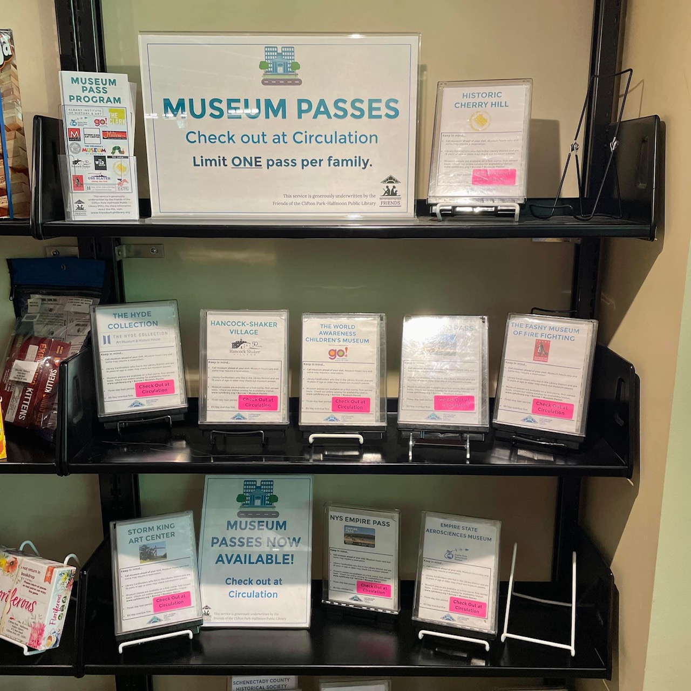
Library Support
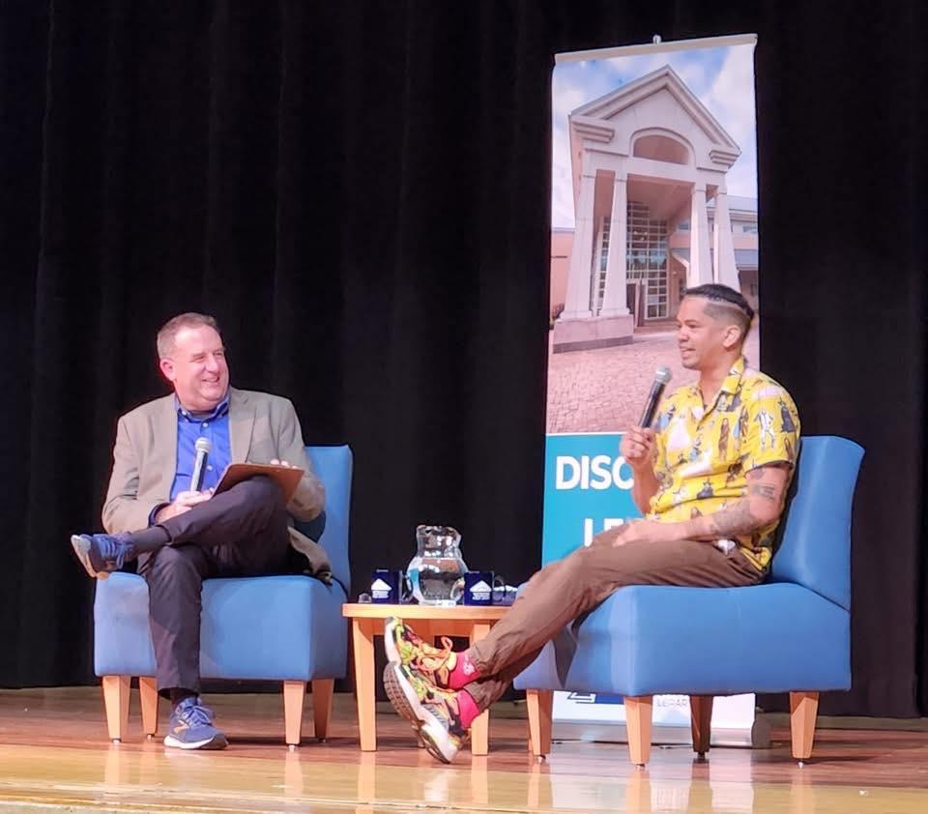
Museum Passes continue to be a popular offering for the library, with passes circulating more than 900 times in 2025 - a 50% increase from just two years ago. The three most popular passes were for the Saratoga Children's Museum, the Empire Pass for NYS Parks, and Mass MoCA. We also added two new passes - for Olana State Historical Site and the Schenectady Civic Playhouse. CPH Friends is proud to underwrite this program so the community can more easily explore our local attractions!

Speaker Visits: CPH Friends sponsored an author visit by Mychal Threets in May. Co-hosted by the library on the Shenendehowa campus, we welcomed a large crowd for “Mychal the Librarian,” a library celebrity who is a strong voice on social media and advocates for mental health and libraries as a welcoming space. Mychal went on to become the new host of Reading Rainbow after his visit.

Engraved Pavers: We administer the Pavers program, located around the library in the outside entrance area, flag pole, and reading garden. This year we added nine engraved pavers that give patrons an opportunity to commemorate a loved one, which also serves as a fundraiser for the library.

LOTE4Kids: CPH Friends sponsored a new addition to the children’s library offerings - an online resource that promotes Languages Other Than English. The resource offers audio-picture books in more than 100 languages to promote reading and multilingualism.

Community Support
CPH Friends continued to support programs that connect the library and community through underwriting support. These include:
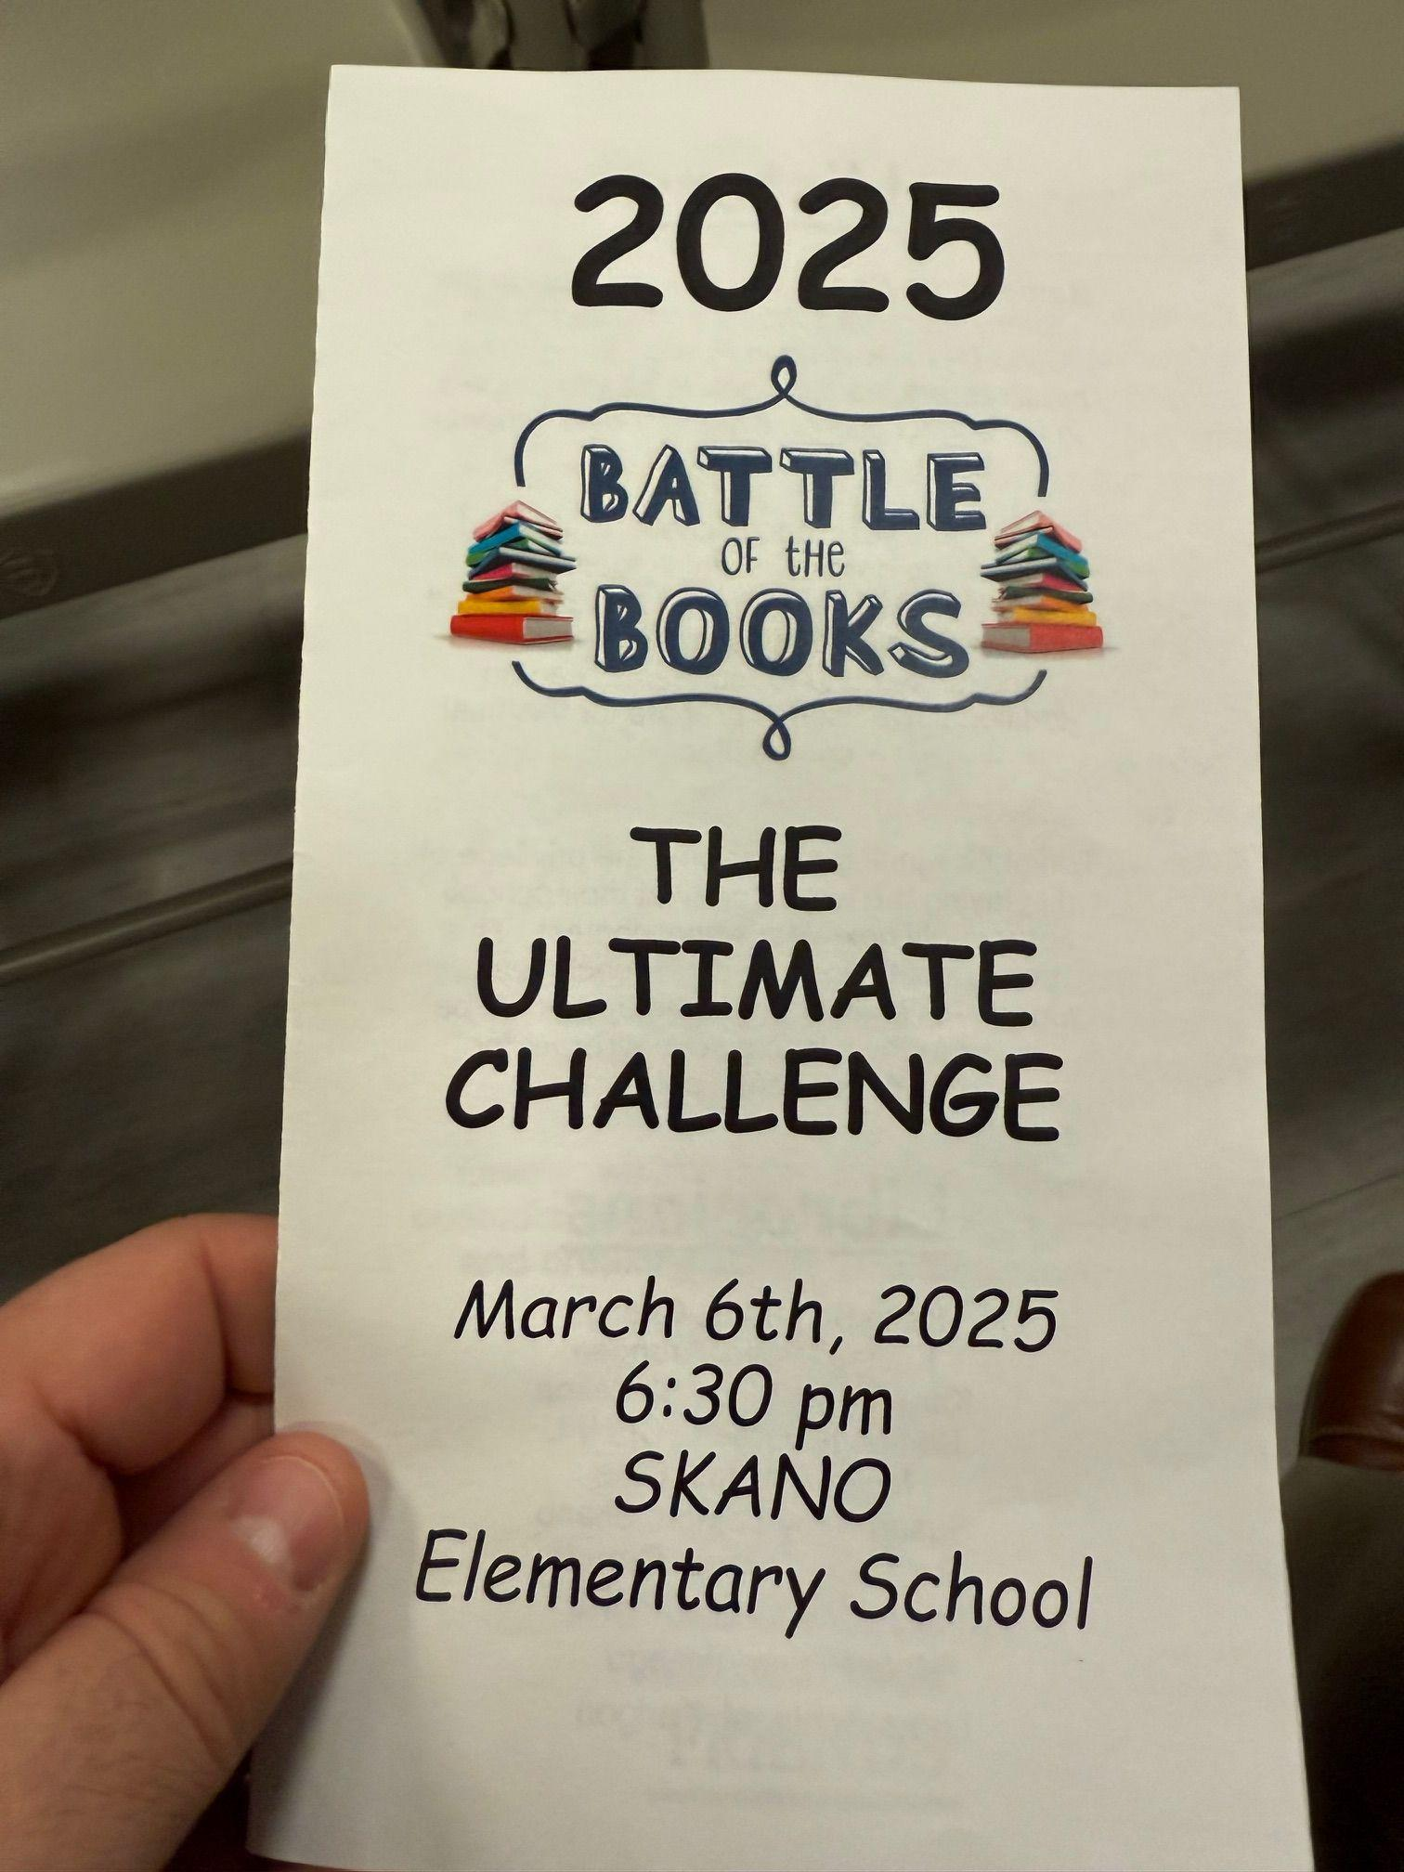
- All-Abilities Art Club: A monthly open studio-style hour for adults of all ages and abilities to come together for art-making and community. Each month features a new material and theme.

- Battle of the Books: Promoting literacy among our young community, CPH Friends sponsors an annual, library district-wide Battle of the Books. Open to fifth graders in each elementary school and fourth- and fifth-graders on library teams, this encourages reading, community, and trivia fun!

- Books for Babies: Twice a year, parents and grandparents in the library district can pick up a packet with information and a board book for a new baby in their lives. In 2025, 125 packets were distributed thanks to the Friends’ sponsorship.

- English Language Learning (ELL) offers classes that include conversation, reading, writing, grammar, vocabulary development, pronunciation, American culture, and current events for all levels of English.

- College Scholarships: CPH Friends provides two $1,000 scholarships each year to two graduating seniors within the library district to use on college-related expenses. We again had a strong pool of applicants in 2025, selecting two Shenendehowa seniors. We awarded the scholarships with a reception before the May CPH Friends Board Meeting.

The Friends of the Library - General Updates
We saw several changes to the board, as founding members Kathy Browne and Jo Anne Robbins stepped down in April and December, respectively. We also brought on three new members - Robin Bauerle, who will take on treasurer duties in 2026, plus Rhoda Pickus and Kelly Tetreault. Board members Ellen Burns, Wilma Jozwiak, and Lisa Totaro, and CPH Friends member Diane Madrigal represented us by speaking at the 2025 New York Library Association (NYLA) conference in Saratoga Springs, alongside library staff Rebecca Verhayden and Amanda Menneto.
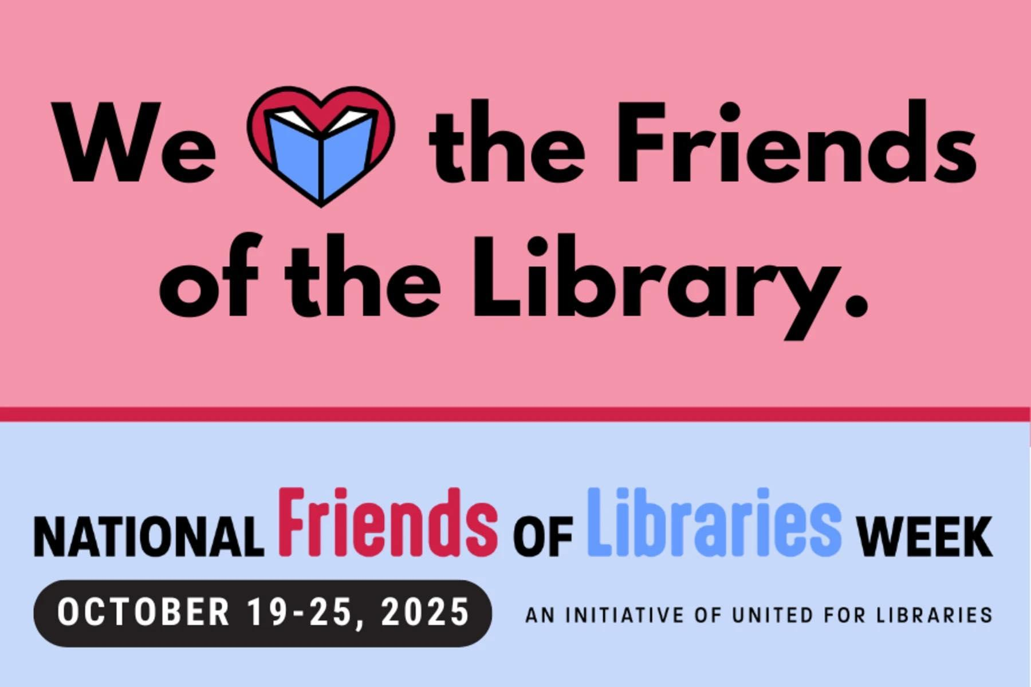
Key communication updates in 2025 included moving our Book Friendly newsletter into a monthly format that links directly to event details or more information on our blog. After many years of our magazine-like PDFs, this change keeps CPH Friends current with modes of communication and technology, and allows our readers to get an at-a-glance of happenings before clicking on things of more interest to them. We also continued to use Facebook and Instagram to educate and inform the community about Friends programs and library services, plus promote a community feeling.
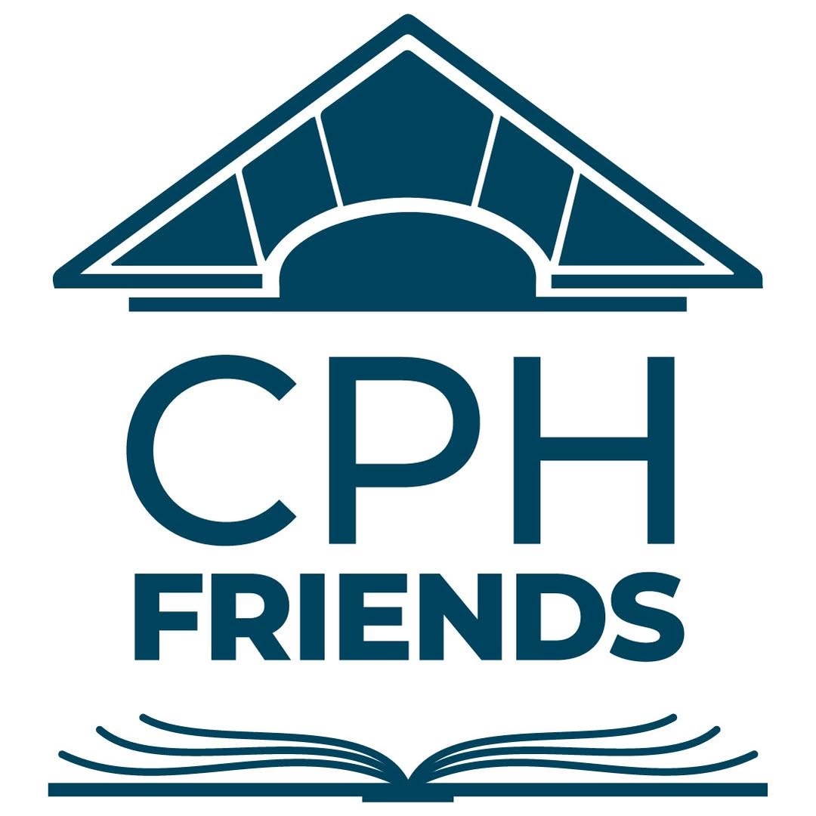
We also introduced a new logo for both the CPH Friends and Two Towns-One Book. These logos align with the branding changes that CPH Library made several years ago, and reinforces the partnership between the organizations. We’ve also adopted a color palette that complements the library’s.

Membership numbers increased more than 12% from year-end 2024 to year-end 2025, representing nearly a 10% increase in revenue. We continue to look for new ways to introduce the Friends to the community and encourage their participation as members.

Our volunteer base remains robust. CPH Friends members also support initiatives with their time, putting in many hours volunteering for efforts including our Two Towns-One Book Community Read Program, Used Book Sales, Crafters Supplies Give and Take, Plant Give and Take, Hospitality Committee, and Membership Committee.
During 2026, we continued a review of the CPH Friends’ Standard Operating Procedures, an important adjunct to our Bylaws that both establish guidelines for good practice and provides support when leadership changes for the Board or committees. This is a work in progress that will continue into 2026.

A Look Ahead
CPH Friends will continue to bring together the library and community in 2026, as our membership and support of our library continue to grow. We will continue to look for fundraising opportunities and community engagement that allow us to expand our impact and serve our community members. Throughout each year, we listen to suggestions from our members, event participants, and community, and incorporate much of the viable feedback.

The Friends of the Clifton Park-Halfmoon Public Library remains a strong organization with an engaged membership, with nearly 200 individuals supporting the library with their volunteer hours. We will continue to look for new ways to support our library and thus, the continuing needs of our community.

Revenues and Expenses for Fiscal Year 2025

CATEGORY | REVENUE | EXPENSE | NET
Donation | 7,118.51 | ---- | 7,118.51
GOTV | ---- | 695.91 | (695.91)
Hospitality | ---- | 111.07 | (111.07)
Library Support | ---- | 26,546.51 | (26,546.51)
Membership | 12,900.28 | 86.55 | 12,813.73
Miscellaneous | 599.91 | 1,199.82 | (599.91)
Museum Pass | ---- | 3,518.00 | (3,518.00)
Organization | ---- | 2,503.26 | (2,503.26
Other Fundraising | 6,309.26 | 102.01 | 6,207.25
Outreach | ---- | ---- | ----
Pavers | 1,250.00 | 450.00 | (800.00)
Publicity | ---- | 183.00 | (183.00)
Scholarship | ---- | 2,000.00 | (2,000.00)
Technology | ---- | 3,713.69 | (3,713.69)
Travel | 18,032.35 | 3,893.22 | 14,139.13
TTOB | 2,189.00 | 3,176.54 | (987.54)
Used Book Sale | 27,469.29 | 871.36 | 26,597.93
Totals | 75,868.60 | 49,050.94 | 26,817.66

